**4A+1 System Design**

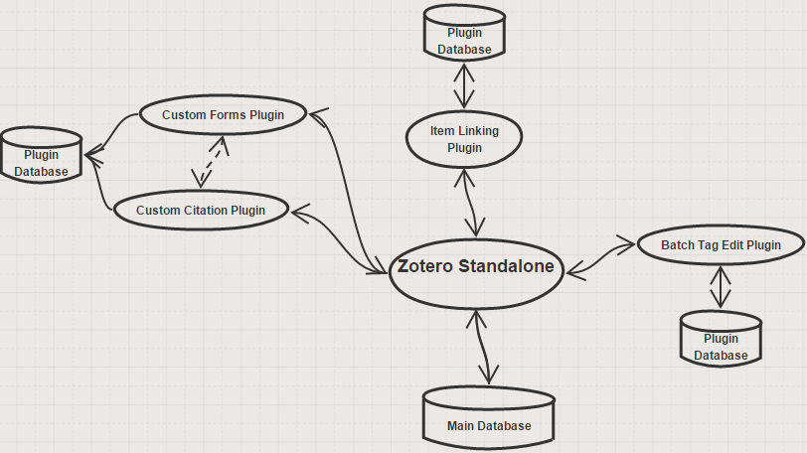 (Made with Sketchboard)

**Diagram Components:**

* **Custom Citation Plugin –** This plugin will allow the user to customize their citation output format when creating a bibliography, by rearranging citation fields and adding their own punctuations where wanted. Custom citation formats can be saved for later use.
* **Custom Forms Plugin** – This plugin will allow the user to add or remove fields to their Zotero items. It will also allow the saving of custom forms into new Zotero items that they can use later.
  + The Custom Citation plugin and Custom Forms plugin will complement each other and will most likely be merged into one plugin at the end. This is because the creation of custom forms also requires custom citations to be able to function to the fullest.
* **Item Linking Plugin –** This plugin will allow the user to link two Zotero items together, such that editing one will also edit the other. This functionality will also work across different libraries.
* **Batch Tag Edit Plugin –** This plugin allows the searching and editing of multiple tags at once, by allowing the selection of multiple tags at the same time (which will allow mass editing). It will use the already implemented search function.